**Journey Through The Bible**

**Cain and Abel**

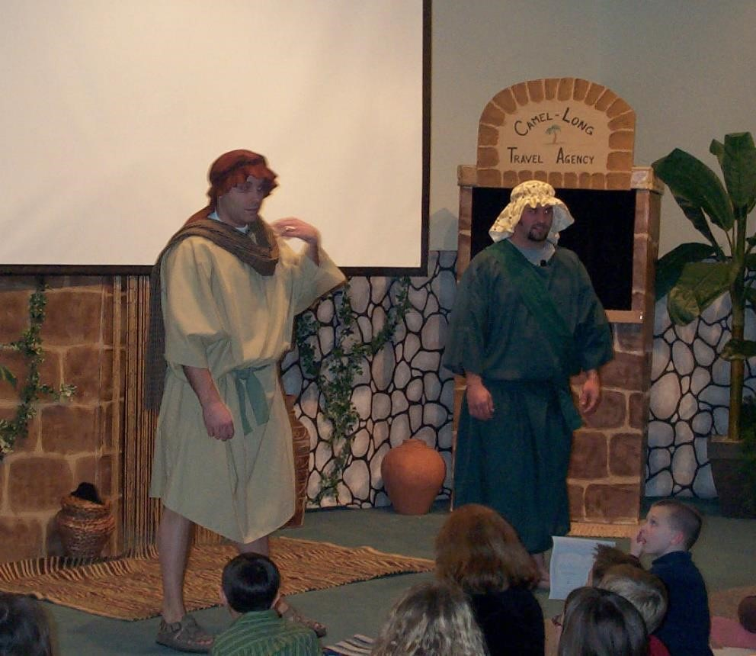

**CAIN AND ABEL**

***Cain:***

I am Cain, the firstborn son of my father Adam and my mother, Eve. I was told that when I was born, my mother said, “I have produced a man with the help of the Lord.”

In time, my mother and father had a second son whom they named Abel. As we grew up, I became the first farmer, a tiller of the ground.

***Abel:***

I am Abel, the younger brother of Cain. I chose to become a shepherd, a keeper of sheep.

***Cain:***

In the course of time, I brought an offering of the fruit of the ground to present to the Lord. I was pleased with my offering, because I had grown it myself.

***Abel:***

I, also, brought an offering to give to the Lord. I picked out the best of my flock. Because my sacrifice was the best I had, my offering was preferred by God to what my brother Cain presented.

***Cain:***

What happened next, I will regret forever. I flew into a jealous rage, took my brother out into the field, and killed my brother, Abel. I became the first murderer.

I tried to hide my guilt, but God knew about my horrible sin.

God said, “Where is your brother Abel?” I said, “I do not know; am I my brother’s keeper?”

The Lord said, “What have you done? Listen; your brother’s blood is crying out to me from the ground.”

The Lord told me that I would be cursed from the ground. When I tilled the ground, it would no longer yield to me its strength.

I was condemned to be a fugitive and a wanderer on the earth.

I said to the Lord, “My punishment is greater than I can bear. Today you have driven me away from the soil, and I shall be hidden from your face, I shall be a fugitive and a wanderer on the earth, and anyone who meets me may kill me.”

The Lord put a mark on me, so that no one who came upon me would kill me. I was forced to leave the presence of the Lord and settled in the land of Nod, east of Eden.

***Abel:***

If you would like to read more about us in the Bible, open the pages to Genesis. Now we would like to ask you some questions. (Prepare several questions to ask the boys and girls.)

**Scripture reading: Genesis 4:1-15**

**Memory Verse:**

1 John 4:21 - He who loves God must love his brother also